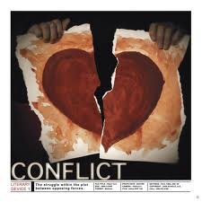
LITERARY TERMINOLOGY English
Allusion -- a familiar reference from literature, the Bible or history
Antagonist -- person of force that opposes the main character
Characterization – method of acquainting a reader with those who populate a story
Conflict -- a struggle between two opposing forces
Connotation -- the social meaning of a word – the charged meaning
Denotation -- the literal/Dictionary meaning
Diction -- an author’s choice of words
Direct Characterization – a character’s personality is explicitly described by author
Dramatic Irony -- audience is more aware of events than the characters
Flashback – scene that interrupts action to show some previous event
Foreshadowing -- use of hints and details that predict future events
Indirect Characterization -- personality is implied by other character’s responses
Protagonist -- central character whom the main conflict revolves
Sensory Images – words and descriptions that appeal to the five senses
Setting – the time and the place of events of a narrative
Situational Irony -- the opposite of what is expected happens
Symbol -- anything used to represent something else
Theme -- main idea or underlying meaning of a literary work
Tone -- the author’s attitude or mood, stated or implied, toward a subject or audience
Verbal Irony -- sometimes translated as sarcasm; words are opposite of meaning

